# LAB REPORT

***Submitted by***

# Ishaan Markanday [RA2011030010082]

***Under the Guidance of***

## Ms. Mahalakshmi P

Assistant professor, NWC

***In partial satisfaction of the requirements for the degree of***

**BACHELOR OF TECHNOLOGY**

### in

**COMPUTER SCIENCE ENGINEERING**

**with specialization in Cyber security.**



### SCHOOL OF COMPUTING

**COLLEGE OF ENGINEERING AND TECHNOLOGY**

**SRM INSTITUTE OF SCIENCE AND TECHNOLOGY**

**KATTANKULATHUR - 603203**

#### JUNE 2022



SRM INSTITUTION OF SCIENCE AND TECHNOLOGY

KATTANKULATHUR-603203

### BONAFIDE CERTIFICATE

Certified that this lab report titled **“Aerolinea”** is the bonafide work done by Ishaan Markanday (RA201103001008) who carried out the lab exercises under my supervision. Certified further, that to the best of my knowledge the work reported herein does not form part of any other work.

**SIGNATURE**

Ms. Mahalakshmi P

**SEPM – Course Faculty**

Assistant professor

Department of NWC

**ABSTRACT**

The flight schedule is the central element of an airline’s planning process, aimed at optimizing the deployment of the airline’s resources in order to meet demands and maximize profits. In this paper, we present an overview of contributions to airline scheduling made by operations research professionals during the past 20 years of so. the overview follows the development of airline scheduling methodology from an early emphasis on standard quantitative optimization techniques to the recent tends towards a structured planning process in which all parts of the airline participate in the “construction” and “evaluation” of schedules, combining exact mathematical programming algorithms and heuristics.

In a commercial airline the flight schedule is

a central element of the planning process. It defines not only the product but to a large extent also the production plan. Given a flight schedule, a significant portion of costs and revenues are fixed. Optimization of the flight schedule, there fore, is central to finding the most efficient and effective deployment of an airline's resources. By implication-if the market and regulatory mechanism works properly-it is also critical for obtaining an air trans portation system which satisfies public objectives.

#### TABLE OF CONTENTS

**Chapter no Title Page no**

Abstract

List of figures

List of Abbreviation’s

1. Problem statement 7
2. Stakeholders and process models 10

1. Identifying requirements 16
2. Project plan and effort 21
3. Work breakdown structure and risk analysis 25
4. System architecture, Use case & class diagram 29
5. Entity Relationship diagram 31
6. Data Flow diagram 34
7. Sequence and collaboration diagram 37
8. Development oof testing framework and user interface 41
9. Test cases and Reporting 43
10. Architecture/Design/framework/Implementation 45

Conclusion

References

Appendix (CODE)

**LIST OF FIGURES**

**Figure no Title Page no**

* + 1. Waterfall Model 11
    2. Work breakdown structure 22
  1. GANTT chart 23
  2. SWOT analysis 23
     1. System architecture 26
     2. Use case diagram 27
     3. Class diagram 28
     4. Entity relationship diagram 30
  3. DFD level 0 33
  4. DFD level 1 33
     1. Sequence diagram 35
     2. Collaboration diagram 36

**LIST OF ABBREVIATIONS**

UML- Unified Modelling Language

WBS-Work Breakdown Structure

UI-User Interface

SWOT-Strength Weakness Opportunities Threats

ER-Entity Relationship

DFD-Data Flow Diagram

GANTT-Generalized activity Normalization Time table

SSL -secure secret locker

Py-python script



**DEPT. Of NWC**

**SRM IST, Kattankulathur – 603 203**

**Course Code: 18CSC206J**

**Course Name: Software Engineering and Project Management**

|  |  |
| --- | --- |
| **Experiment No** | 1 |
| **Title of Experiment** | To identify the Software Project, Create Business Case, Arrive at a  Problem Statement |
| **Name of the candidate** | Ishaan Markanday |
| **Team Members** | Saksham, Veerendra Nadh Matsa |
| **Register Number** | RA2011030010082 |
| **Date of Experiment** | 07/03/2022 |

**Mark Split Up**

|  |  |  |  |  |  |
| --- | --- | --- | --- | --- | --- |
| **S.No** |  | **Description** |  | **Maximum Mark** | **Mark Obtained** |
| 1 | Exercise |  |  | 5 |  |
| 2 | Viva |  |  | 5 |  |
|  |  |  | **Total** | **10** |  |

##### Staff Signature with date

**Aim**

To Frame a project team, analyze and identify a Software project. To create a business

case and Arrive at a Problem Statement for the <title of the project>

**Team Members:**

|  |  |  |  |
| --- | --- | --- | --- |
| **Sl No** | **Register No** | **Name** | **Role** |
| **1** | **RA2011030010082** | **Ishaan Markanday** | **Lead** |
| **2** | **RA2011030010081** | **Veerendra Nadh Matsa** | **Member** |
| **3** | **RA2011030010074** | **SAKSHAM** | **Member** |

**Project Title:**

AEROLINEA (Flight Management System)

**Project Description**

Business Case

<Incorporate the Business Case template>

Result

Thus, the project team formed, the project is described, the business case was prepared and the problem statement was arrived.

|  |  |
| --- | --- |
| **DATE** | 14/03/2022 |
| **SUBMITTED BY** | Ishaan Markanday, Veerendra Nadh Matsa, Saksham |
| **TITLE / ROLE** | AEROLINEA (Flight Management System) |

## ONE PAGE BUSINESS CASE TEMPLATE

### THE PROJECT

In bullet points, describe the problem this project aims to solve or the opportunity it aims to develop.

|  |  |
| --- | --- |
| ● | This project helps the airport authorities to keep a track record of flights,adding or upgrading flights and updates on flight details whether the flight is delayed or scheduled. |

### THE HISTORY

In bullet points, describe the current situation.

|  |  |
| --- | --- |
| ● | For time being the program is under early stage |
| ● | learning python tkinter to make the project |

### LIMITATIONS

List what could prevent the success of the project, such as the need for expensive equipment, bad weather, lack of special training, etc.

only admin has all the powers to do changes in it and it has very basic ui

### APPROACH

List what is needed to complete the project.

|  |  |
| --- | --- |
| ● | Python |
| ● | Tkinter |

### BENEFITS

In bullet points, list the benefits that this project will bring to the organization.

|  |  |
| --- | --- |
| ● | It helps the airport authorities to keep records of flight and updates the flight details. |

9

10



**DEPT. Of NWC**

### SRM IST, Kattankulathur – 603 203

**Course Code: 18CSC206J**

#### Course Name: Software Engineering and Project Management

|  |  |
| --- | --- |
| **Experiment No** | 2 |
| **Title of Experiment** | ***Identification of Project Methodology and Stakeholder***  ***Description template*** |
| **Name of the candidate** | VEERENDRA NADH MATSASAKSHAM |
| **Team Members** | Ishaan Markanday, Veerendra Nadh Matsa |
| **Register Number** | RA2011030010081RA2011030010074 |
| **Date of Experiment** |  |

#### Mark Split Up

|  |  |  |  |  |
| --- | --- | --- | --- | --- |
| **S.No** | **Description** |  | **Maximum Mark** | **Mark Obtained** |
| 1 | Exercise |  | 5 |  |
| 2 | Viva |  | 5 |  |
|  |  | **Total** | **10** |  |

### Staff Signature with date

#### Aim

To identify the appropriate Process Model for the project and prepare Stakeholder and User

Description.

**Team Members:**

|  |  |  |  |
| --- | --- | --- | --- |
| **Sl No** | **Register No** | **Name** | **Role** |
| **1** | **RA2011030010082** | **Ishaan markanday** | **Rep/Member** |
| **2** | **RA2011030010074** | **Saksham** | **Member** |
| **3** | **RA2011030010081** | **Veerendra nadh matsa** | **Member** |

#### Project Title: Aerolinea(Flight management system) Selection of Methodology

Waterfall is the most conventional software development methodology.

In fact, it has been one of the most popular approaches for web development projects for several decades due to its plan-driven approach. The Waterfall approach requires a lot of structure and documentation. The process is divided into several stages that form a sequence: The first stage is critical and requires a complete understanding of the project’s demands and scope by both the developers and the product owners. Waterfall will require a full restart. As a result, projects managed under the Waterfall method might require much more time. On the other hand, it is great for ensuring that all deliverables meet expectations and it allows for easily measuring the progress since you see the full scope of the project in advance.



Analysis

Design

Implementation

Testing

Maintenance

##### Incorporate *Identification of Project Methodology and Stakeholder Description template*

|  |  |  |  |  |
| --- | --- | --- | --- | --- |
| Stakeholder  Name | Activity/ Area /Phase | Interest | Influence | Priority (High/ Medium/ Low) |
| Owner/admin | Modifying the schedules. | High | High | 1 |
| supervisor | Monitors the work | High | High | 2 |
| Investor | Provides financial resources | High | Low | 2 |
| User | Check the availability and provide feedback | Low | Low | 3 |

Result

Thus the Project Methodology was identified stakeholders were described.



**Department Of Networking and Communications**

### SRM IST, Kattankulathur – 603 203

#### Course Code: 18CSC206J Course Name: Software Engineering and Project Management

|  |  |
| --- | --- |
| **Experiment No** | 3 |
| **Title of Experiment** | System, Functional and Non-Functional Requirements of the  Project |
| **Name of the candidate** | SAKSHAM |
| **Team Members** | Ishaan Markanday,Veerendra Matsa Nadh |
| **Register Number** | RA2011030010074 |
| **Date of Experiment** | 23/02/2022 |

#### Mark Split Up

|  |  |  |  |  |
| --- | --- | --- | --- | --- |
| **S.No** | **Description** |  | **Maximum Mark** | **Mark Obtained** |
| 1 | Exercise |  | 5 |  |
| 2 | Viva |  | 5 |  |
|  |  | **Total** | **10** |  |

### Staff Signature with date

#### Aim

To identify the system, functional and non-functional requirements for the project.

**Team Members:**

|  |  |  |  |
| --- | --- | --- | --- |
| **S No** | **Register No** | **Name** | **Role** |
| **1** | **RA2011030010082** | **Ishaan Markanday** | **Rep/Member** |
| **2** | **RA2011030010081** | **Veerendra Matsa Nadh** | **Member** |
| **3** | **RA2011030010074** | **Saksham** | **Member** |

**Project Title: < >**

### Aerolinea

#### System Requirements

* Processor- Minimum Pentium IV
* Harddisk- Minimum 100GB
* RAM- Minimum 2 GB

#### Functional Requirements

* Administrative Functions- Permissions
* System Shut down at the time of cyber attack
* Getting input from the admin and supervisor
* Authentication-Verification email is sent to user whenever he/she registers and verifies at the time of login

#### Non-Functional Requirements

* Security
* Reliability
* Availability
* Mantainability
* Supportability

Result

Thus the requirements were identified and accordingly described.



**Department of Networking and Communications**

#### SRM IST, Kattankulathur – 603 203

**Course Code: 18CSC206J**

##### Course Name: Software Engineering and Project Management

|  |  |
| --- | --- |
| **Experiment No** | 4 |
| **Title of Experiment** | Prepare Project Plan based on scope, Calculate Project effort based on resources and Job roles and responsibilities |
| **Name of the candidate** | Ve**SAKSHAM**erendra nadh matsa |
| **Team Members** | Ishaan Markanday,Veerendra Matsa Nadh |
| **Register Number** | RA2011030010074 |
| **Date of Experiment** | 22-03-2022 |

##### Mark Split Up

|  |  |  |  |  |
| --- | --- | --- | --- | --- |
| **S.No** | **Description** |  | **Maximum Mark** | **Mark Obtained** |
| 1 | Exercise |  | 5 |  |
| 2 | Viva |  | 5 |  |
|  |  | **Total** | **10** |  |

#### Staff Signature with date

##### Aim

To Prepare Project Plan based on scope, Calculate Project effort based on resources, Find

Job roles and responsibilities

**Team Members:**

|  |  |  |  |
| --- | --- | --- | --- |
| **Sl No** | **Register No** | **Name** | **Role** |
| **1** | RA2011030010082 | Ishaan markanday | **Lead** |
| **2** | RA2011030010081 | Veerendra nadh matsa | **Member** |
| **3** | RA2011030010074 | Saksham | **Member** |

**Requirements:**

1. Project Management Plan

Describe the key issues driving the project. **[Min 3 Focus Areas]**

|  |  |
| --- | --- |
|  | |
| **Focus Area** |  |
| **Details** |
| Schedule Management | Define Milestones  Schedule Control |
| Cost Management | Estimate Effort  Assign Team  Budget Control |
| Quality Management | Quality Assurance: Quality assurance will be managed including governance, roles and responsibilities, tools and techniques and reporting  Quality Control: Specify the mechanisms to be used to measure and control the quality of the work products |
| Resource Management | Estimate and manage the need  People: People & Skills Required  Finance: Budget Required  Physical: Facilities, IT Infrastructure |
| Stakeholder | Identifying, Analyzing, Engaging Stakeholders |

|  |  |
| --- | --- |
| Communication Management | Determine communication requirements, roles and responsibilities, tools and techniques. [Type of  Communication, Schedule, Mechanism Recipient] |
| Risk Management | Identifying, analyzing, and prioritizing project risks |

1. Estimation 
   1. Effort and Cost Estimation

|  |  |  |  |  |
| --- | --- | --- | --- | --- |
| **Activity Description** | **Sub-Task** | **Sub-Task Description** | **Effort (in hours)** | **Cost in**  **INR** |
| Design the user screen | E1R1A1T1  (Effort-  RequirementActivityTask) | Confirm the user requirements  (acceptance criteria) | 6 | 2500 |
| E1R1A1T2 | Distribution of designing work to the team | 2 | 1000 |
| E1R1A1T3 | Designing the User  Interface | 48 | 24000 |
| Identify Data Source for displaying units of Energy  Consumption |  | Go through Interface contract (Application Data Exchange) documents | 5 | 2500 |
|  | Document | 2 | 1000 |

|  |  |
| --- | --- |
| **Effort (hr)** | **Cost (INR)** |
| 1 | 500 |

* 1. Infrastructure/Resource Cost [CapEx]

< OneTime Infra requirements >

|  |  |  |  |  |
| --- | --- | --- | --- | --- |
| **Infrastructure**  **Requirement** | **Qty** |  | **Cost per qty** | **Cost per item** |
| IR1 | PC’s | | 3 | 50,000 |
| IR2 | Wifi | | 1 | 3000 |
| IR3 | Furniture | | 3 | 5000 |
| IR4 | Hosting Server | | 1 | 6000 |

* 1. Maintenance and Support Cost [OpEx]

|  |  |  |  |  |
| --- | --- | --- | --- | --- |
| **Category** | **Details** | **Qty** | **Cost per qty per annum** | **Cost per item** |
| People | Network, System,  Middleware and DB admin  Developer, Support  Consultant | 3 | 2,000,000 | 6,000,000 |
| License | Operating System  Database  Middleware  IDE | 10 | 10000 | 100,000 |
| Infrastructures | Server, Storage and Network | 15 | 20000 | 400,000 |

3.Project Team Formation

* 1. Identification Team members

|  |  |  |
| --- | --- | --- |
| **Name** | **Role** | **Responsibilities** |
| Ishaan | Key Business User (Product  Owner) | Provide clear business and user requirements |
| Saksham | Project Manager | Manage the project |
| veerendra | Business Analyst | Discuss and Document Requirements |
| Saksham | Technical Lead | Design the end-to-end architecture |
| ishaan | UX Designer | Design the user experience |
| veerendra ,Saksham | Frontend Developer | Develop user interface |
| ishaan | Backend Developer | Design, Develop and Unit Test  Services/API/DB |
| Saksham | Cloud Architect | Design the cost effective, highly available and scalable architecture |
| Ishaan | Cloud Operations | Provision required Services |
| veerendra | Tester | Define Test Cases and Perform Testing |

* 1. Responsibility Assignment Matrix

|  |  |  |  |  |
| --- | --- | --- | --- | --- |
| **RACI Matrix** |  | **Team Members** | |  |
| **Activity** | **Name (BA)** | **Name (Developer)** | **Name (Project**  **Manager)** | **Key Business**  **User** |
| User Requirement  Documentation | A | C/I | I | R |
|  | Veerendra | Saksham | ishaan | ishaan |

|  |  |
| --- | --- |
| A | Accountable |
| R | Responsible |
| C | Consult |
| I | Inform |

**Result:**

Thus, the Project Plan was documented successfully.



**Department of Networking and Communications**

**SRM IST, Kattankulathur – 603 203**

**Course Code: 18CSC206J**

**Course Name: Software Engineering and Project Management**

|  |  |
| --- | --- |
| **Experiment No** | 5 |
| **Title of Experiment** | Prepare Work breakdown structure, Timeline chart, Risk identification table |
| **Name of the candidate** | SAKSHAM |
| **Team Members** | Ishaan Markanday,Veerendra Nadh Matsa |
| **Register Number** | RA2011030010074 |
| **Date of Experiment** | 25/03/22 |

**Mark Split Up**

|  |  |  |  |  |  |
| --- | --- | --- | --- | --- | --- |
| **S.No** |  | **Description** |  | **Maximum Mark** | **Mark Obtained** |
| 1 | Exercise |  |  | 5 |  |
| 2 | Viva |  |  | 5 |  |
|  |  |  | **Total** | **10** |  |

##### Staff Signature with date

**Aim**

To Prepare Work breakdown structure, Timeline chart and Risk identification table

**Team Members:**

|  |  |  |  |
| --- | --- | --- | --- |
| **Sl No** | **Register No** | **Name** | **Role** |
| **1** | Ra2011030010082 | Ishaan Markanday | **Rep** |
| **2** | Ra2011030010081 | Veerendra Nadh Matsa | **Member** |
| **3** | Ra2011030010074 | Saksham | **Member** |

**WBS –**

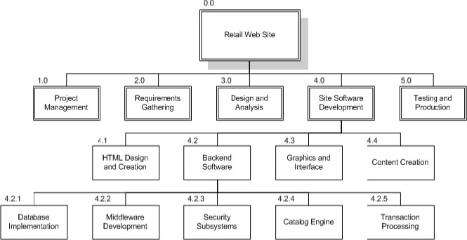

Python

Tkinter(GUI)

* 0.0 Retail Web Site
* 1.0 Project Management
* 2.0 Requirements Gathering
* 3.0 Analysis & Design
* 4.0 Site Software Development

◦ 4.1 PYTHON

◦ 4.2 Backend Software

* + 4.2.1 Database Implementation
  + 4.2.2 Middleware Development
  + 4.2.3 Security Subsystems
  + 4.2.4 Catalog Engine



◦ 4.3 Graphics and Interface (Tkinter)

◦ 4.4 Content Creation

* 5.0 Testing and Production

**TIMELINE – GANTT CHART**

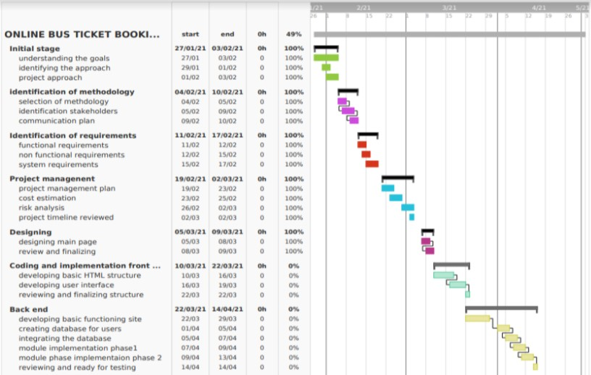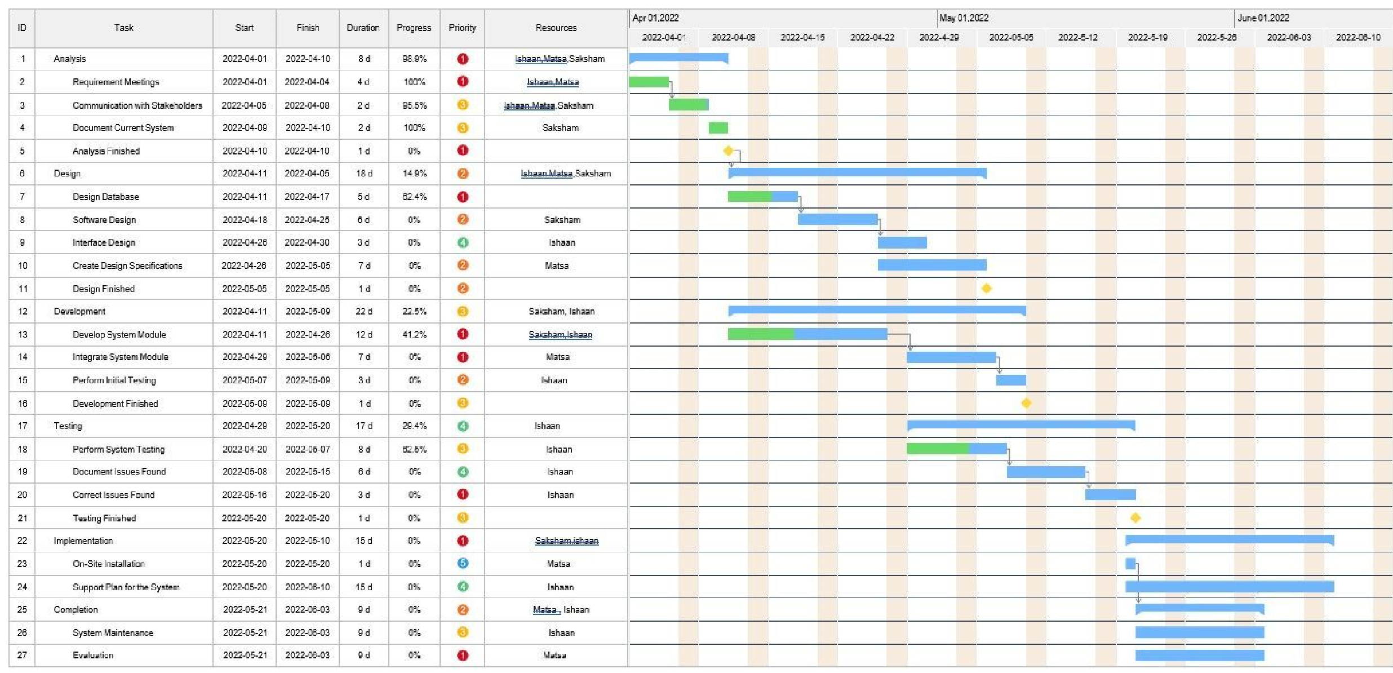

**RISK ANALYSIS – SWOT & RMMM**

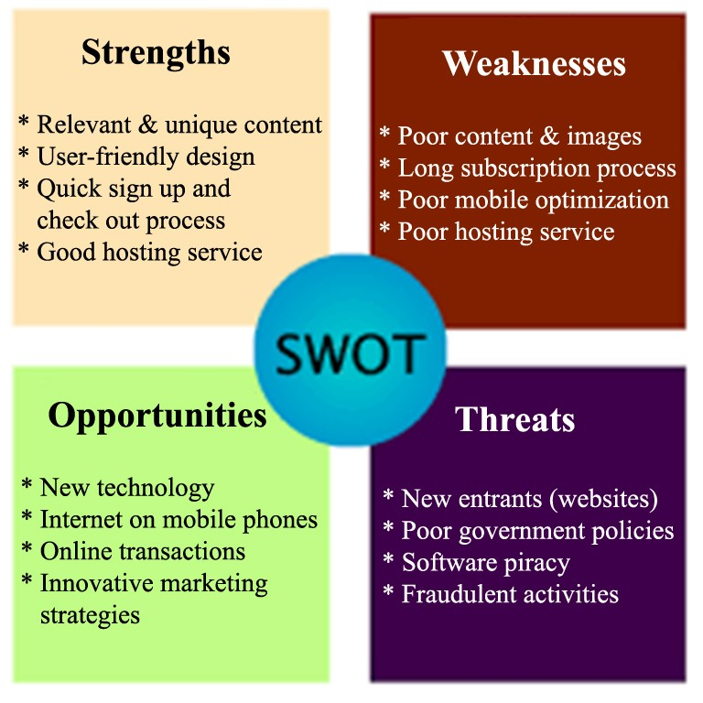

### RISK MANAGEMENT FRAMEWORK

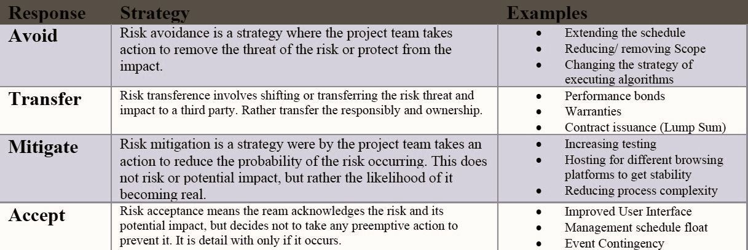

Result-:

Thus, the work breakdown structure with timeline chart and risk table were formulated successfully.



**Department of Networking and Communications**

#### SRM IST, Kattankulathur – 603 203

**Course Code: 18CSC206J**

##### Course Name: Software Engineering and Project Management

|  |  |
| --- | --- |
| **Experiment No** | 6 |
| **Title of Experiment** | Design a System Architecture, Use Case and Class Diagram |
| **Name of the candidate** | SAKSHAM |
| **Team Members** | Verendra Matsa Nadh,Ishaan Markanday |
| **Register Number** | RA2011030010074 |
| **Date of Experiment** | 14/04/22 |

##### Mark Split Up

|  |  |  |  |  |
| --- | --- | --- | --- | --- |
| **S.No** | **Description** |  | **Maximum Mark** | **Mark Obtained** |
| 1 | Exercise |  | 5 |  |
| 2 | Viva |  | 5 |  |
|  |  | **Total** | **10** |  |

#### Staff Signature with date

##### Aim

To Design a System Architecture, Use case and Class Diagram

**Team Members:**

|  |  |  |  |
| --- | --- | --- | --- |
| **Sl No** | **Register No** | **Name** | **Role** |
| **1** | **RA2011030010082** | **Ishaan Markanday** | **Rep** |
| **2** | **RA2011030010081** | **Veerendra Matsa Nadh** | **Member** |
| **3** | **RA2011030010074** | **Saksham** | **Member** |

**Title-:**

**AEROLINEA**

##### SYSTEM ARCHITECTURE –

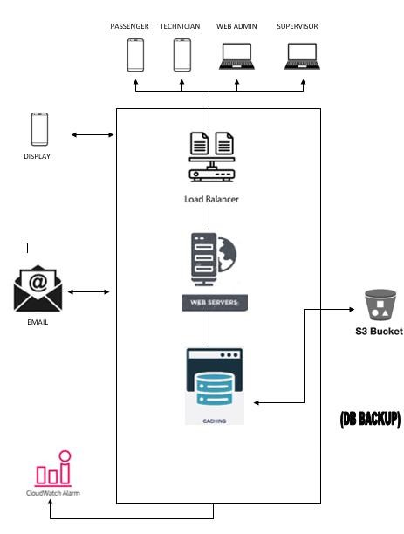

##### USE CASE DIAGRAM –

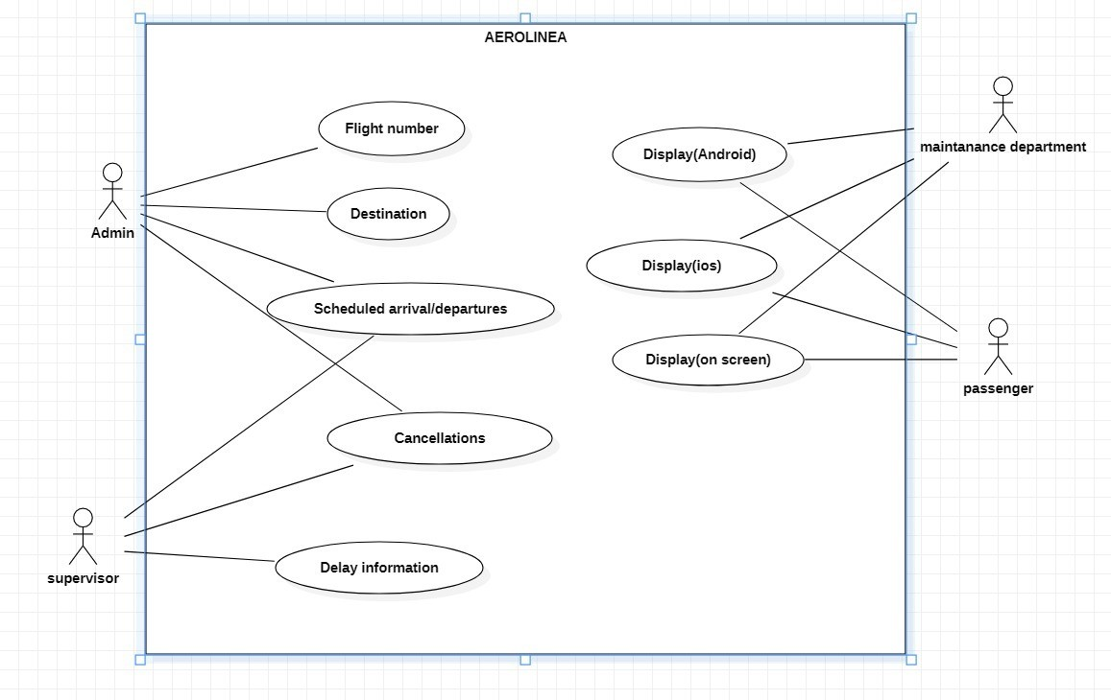

##### CLASS DIAGRAM –

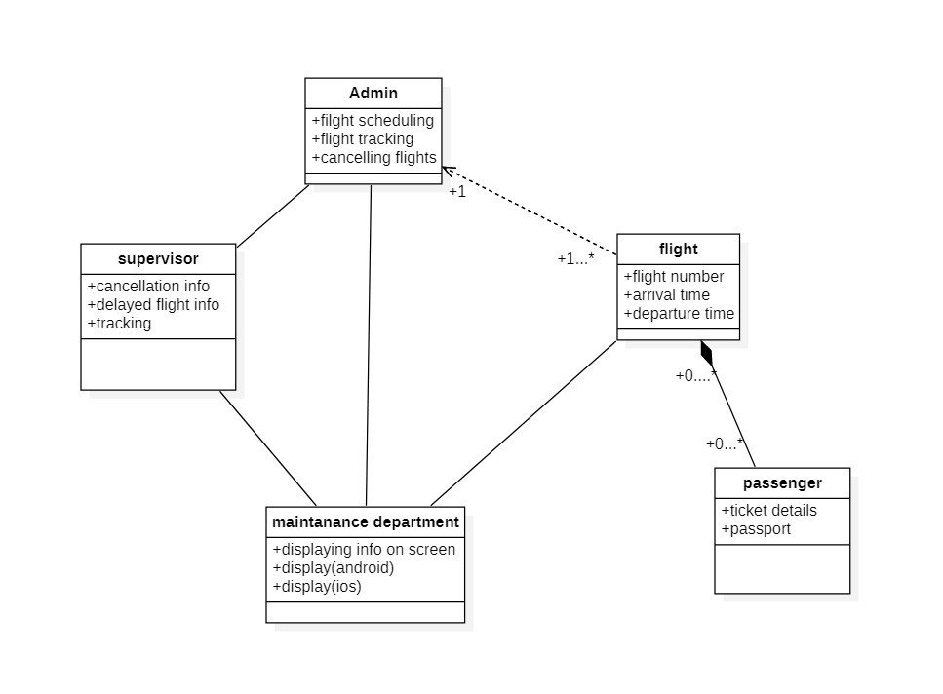

Result:

Thus, the system architecture, use case and class diagram created successfully.



**School of Computing**

#### SRM IST, Kattankulathur – 603 203

**Course Code: 18CSC206J**

##### Course Name: Software Engineering and Project Management

|  |  |
| --- | --- |
| **Experiment No** | 7 |
| **Title of Experiment** | Design a Entity relationship diagram |
| **Name of the candidate** | SAKSHAM |
| **Team Members** | VEERENDRA NADH MATSA,ISHAAN MARKANDAY |
| **Register Number** | RA2011030010074 |
| **Date of Experiment** | 27/04/22 |

##### Mark Split Up

|  |  |  |  |  |
| --- | --- | --- | --- | --- |
| **S. No** | **Description** |  | **Maximum Mark** | **Mark Obtained** |
| 1 | Exercise |  | 5 |  |
| 2 | Viva |  | 5 |  |
|  |  | **Total** | **10** |  |

#### Staff Signature with date

##### Aim

To create the Entity Relationship Diagram

**Team Members:**

|  |  |  |  |
| --- | --- | --- | --- |
| **S No** | **Register No** | **Name** | **Role** |
| **1** | **RA2011030010082** | **ISHAAN MARKANDAY** | **Rep** |
| **2** | **RA2011030010081** | **VEERENDRA NADH MATSA** | **Member** |
| **3** | **RA2011030010074** | **SAKSHAM** | **Member** |

**ER**

**DIAGRAM**

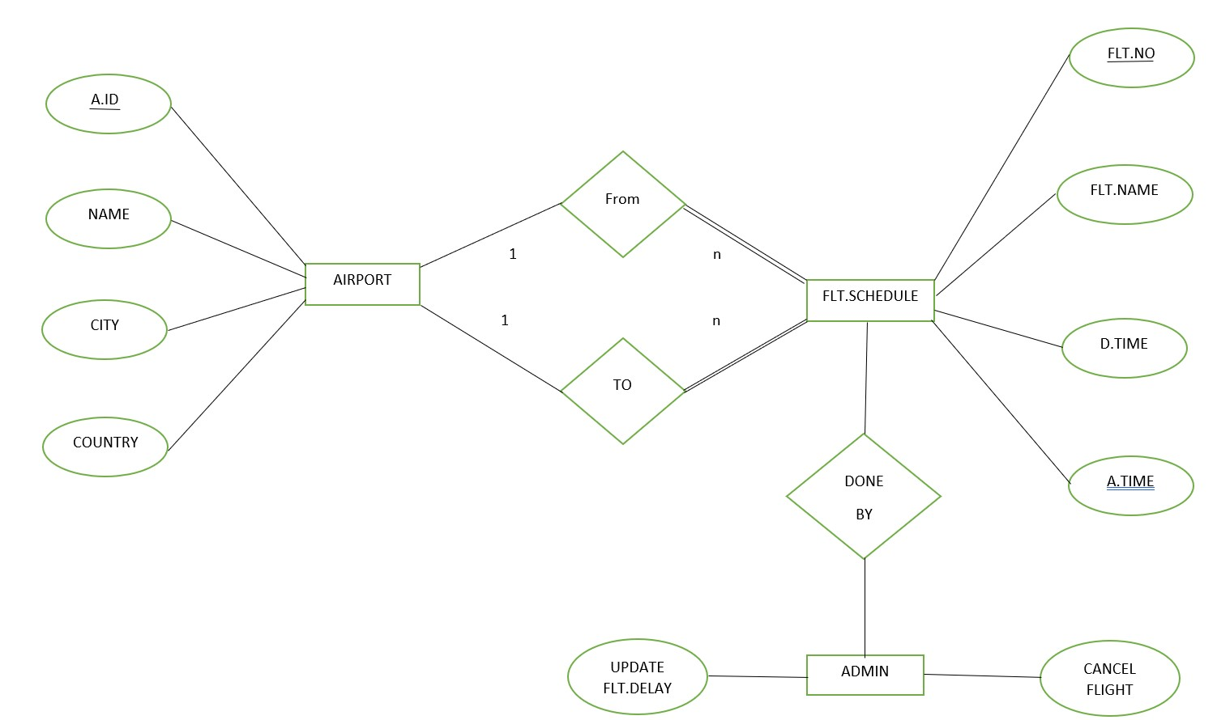

Result:

Thus, the entity relationship diagram was created successfully.



#### School of Computing

**SRM IST, Kattankulathur – 603 203 Course Code: 18CSC206J**

##### Course Name: Software Engineering and Project Management

|  |  |
| --- | --- |
| **Experiment No** | 8 |
| **Title of Experiment** | Develop a Data Flow Diagram (Process-Up to Level 1) |
| **Name of the candidate** | Veerendra nadh Matsa  SAKSHAM |
| **Team Members** | Saksham ,Ishaan Markanday  Ishaan, Veerendra Matsa nadh |
| **Register Number** | RA2011030010081 RA2011030010074 |
| **Date of Experiment** |  |

##### Mark Split Up

|  |  |  |  |  |
| --- | --- | --- | --- | --- |
| **S. No** | **Description** |  | **Maximum Mark** | **Mark Obtained** |
| 1 | Exercise |  | 5 |  |
| 2 | Viva |  | 5 |  |
|  |  | **Total** | **10** |  |

#### Staff Signature with date

##### Aim

To develop the data flow diagram up to level 1 for the <project name>

**Team Members:**

|  |  |  |  |
| --- | --- | --- | --- |
| **S No** | **Register No** | **Name** | **Role** |
| **1** | **RA2011030010082** | **Ishaan MArkanday** | **Rep** |
| **2** | **RA2011030010081** | **Veerendra Nadh Matsa** | **Member** |
| **3** | **RA2011030010074** | **Saksham** | **Member** |

##### Data Flow Diagram

The DFD takes an input-process-output view of a system. That is, data objects flow into the software, are transformed by processing elements, and resultant data objects flow out of the software. Data objects are represented by labeled arrows, and transformations are represented by circles (also called bubbles). The DFD is presented in a hierarchical fashion. That is, the first data flow model (sometimes called a level 0 DFD or context diagram) represents the system as a whole. Subsequent data flow diagrams refine the context diagram, providing increasing detail with each subsequent level.

The data flow diagram enables you to develop models of the information domain and functional domain. As the DFD is refined into greater levels of detail, you perform an implicit functional decomposition of the system. At the same time, the DFD refinement results in a corresponding refinement of data as it moves through the processes that embody the application.

A few simple guidelines can aid immeasurably during the derivation of a data flow diagram:

1. Level 0 data flow diagram should depict the software/system as a single bubble;
2. Primary input and output should be carefully noted;
3. Refinement should begin by isolating candidate processes, data objects, and data stores to be represented at the next level;
4. All arrows and bubbles should be labeled with meaningful names;
5. Information flow continuity must be maintained from level to level and
6. One bubble at a time should be refined. There is a natural tendency to overcomplicate the data flow diagram. This occurs when you attempt to show too much detail too early or represent procedural aspects of the software in lieu of information flow.

###### DFD Level 0

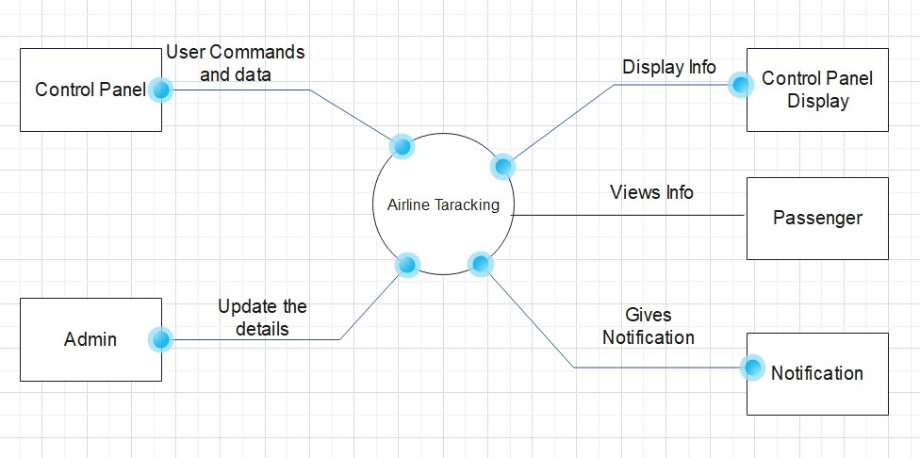

###### DFD Level 1

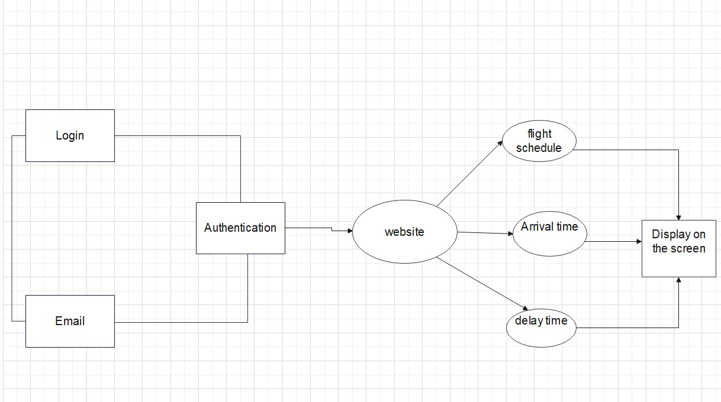

Result:

Thus, the data flow diagrams have been created for the aerolinea.



#### School of Computing

**SRM IST, Kattankulathur – 603 203 Course Code: 18CSC206J**

##### Course Name: Software Engineering and Project Management

|  |  |
| --- | --- |
| **Experiment No** | 9 |
| **Title of Experiment** | Design a Sequence and Collaboration Diagram |
| **Name of the candidate** | Veerendra nadh Matsa  SAKSHAM |
| **Team Members** | Saksham, Ishaan markanday Ishaan,Veerendra Matsa |
| **Register Number** | RA2011030010081 RA2011030010074 |
| **Date of Experiment** |  |

##### Mark Split Up

|  |  |  |  |  |
| --- | --- | --- | --- | --- |
| **S. No** | **Description** |  | **Maximum Mark** | **Mark Obtained** |
| 1 | Exercise |  | 5 |  |
| 2 | Viva |  | 5 |  |
|  |  | **Total** | **10** |  |

#### Staff Signature with date

##### Aim

To create the sequence and collaboration diagram for the <project name>

**Team Members:**

|  |  |  |  |
| --- | --- | --- | --- |
| **S No** | **Register No** | **Name** | **Role** |
| **1** | **RA2011030010082** | **Ishaan Markanday** | **Rep/Member** |
| **2** | **RA2011030010081** | **Veerendra nadh Matsa** | **Member** |
| **3** | **RA2011030010074** | **Saksham** | **Member** |

**Sequence Diagram:**

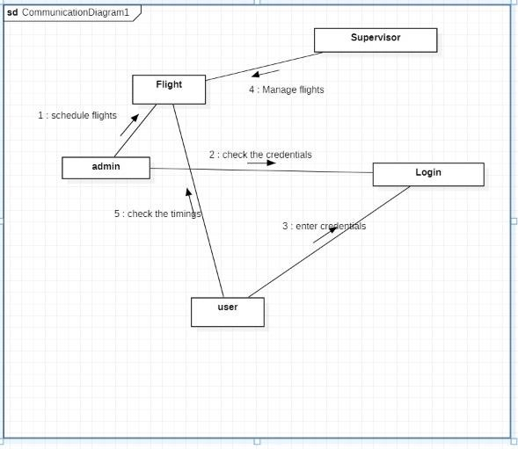

**Collaboration diagram**:

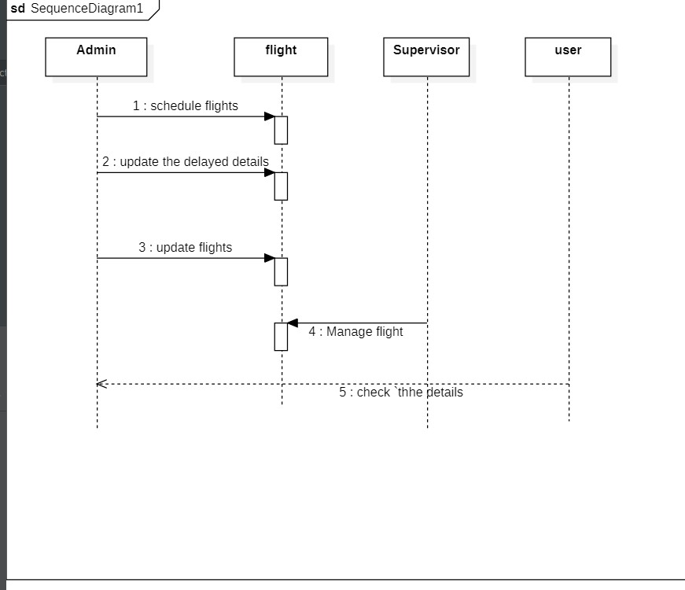

Result:

Thus, the sequence and collaboration diagrams were created for the Aerolinea.

##### */ For Example

###### Sequence Diagram

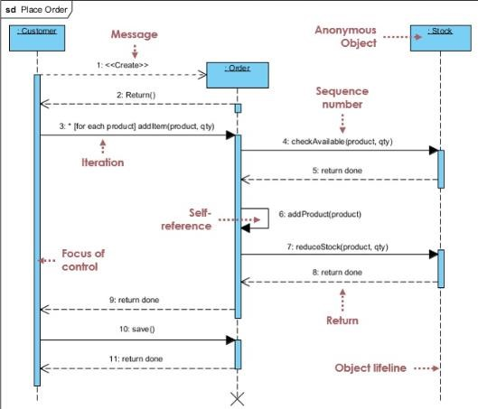

###### Collaboration Diagram

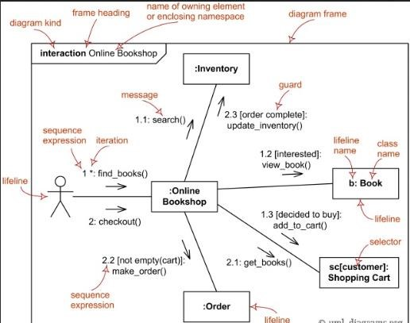



#### School of Computing

**SRM IST, Kattankulathur – 603 203 Course Code: 18CSC206J**

##### Course Name: Software Engineering and Project Management

|  |  |
| --- | --- |
| **Experiment No** | 10 |
| **Title of Experiment** | Develop a Testing Framework/User Interface |
| **Name of the candidate** | Veerendra nadh Matsa  Saksham |
| **Team Members** | Saksham,ishaan Markanday  Ishaan,Veerendra Matsa Nadh |
| **Register Number** | RA2011030010081 RA2011030010074 |
| **Date of Experiment** | 23-6-22 |

##### Mark Split Up

|  |  |  |  |  |
| --- | --- | --- | --- | --- |
| **S. No** | **Description** |  | **Maximum Mark** | **Mark Obtained** |
| 1 | Exercise |  | 5 |  |
| 2 | Viva |  | 5 |  |
|  |  | **Total** | **10** |  |

#### Staff Signature with date

##### Aim

To develop the testing framework and/or user interface framework for the <project name>

**Team Members:**

|  |  |  |  |
| --- | --- | --- | --- |
| **S No** | **Register No** | **Name** | **Role** |
| **1** | **RA2011030010082** | **Ishaan** | **Rep/Member** |
| **2** | **RA2011030010081** | **Veerendra nadh** | **Member** |
| **3** | **RA2011030010074** | **Saksham** | **Member** |

**USER INTERFACE FRAMEWORK**:

***Landing page screen***

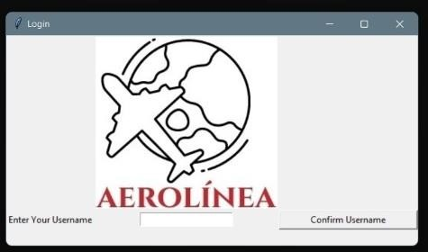

##### Login screen

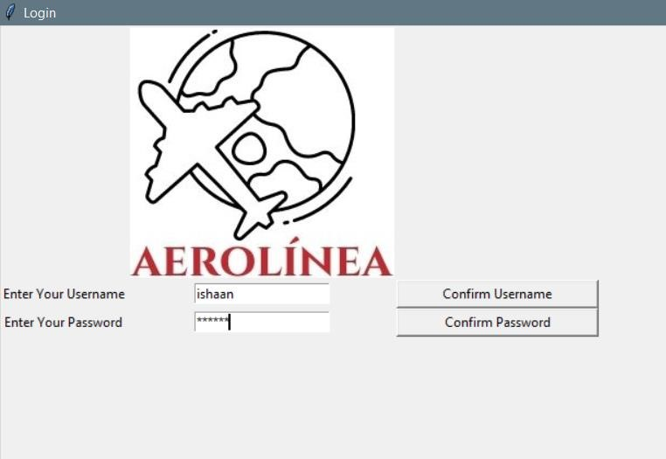

##### Flight schedule screen

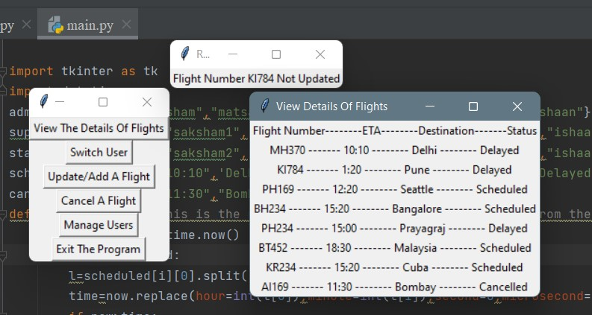

**TESTING FRAMEWORK**

**Functional requirements**

|  |  |  |  |
| --- | --- | --- | --- |
| Test area | INPUT | Testing Method | Tools |
| 1.login module | Login username and password | Manual | - |
| 2.Responsiveness | UI/UX | Automated | Maze, user testing.com |

**Non functional requirements**

|  |  |  |
| --- | --- | --- |
| Test area | Testing methods | Tools |
| Usability | Automated | Userfeel |
| Security | Automated | SSL |
| Performance | Automated | Loadninja |
| Scalability | Manual | - |

Result:

Thus, the testing framework/user interface framework has been created for the Aerolinea.



#### School of Computing

**SRM IST, Kattankulathur – 603 203 Course Code: 18CSC206J**

##### Course Name: Software Engineering and Project Management

|  |  |
| --- | --- |
| **Experiment No** | 11 |
| **Title of Experiment** | Test Cases |
| **Name of the candidate** | Veerendra nadh Matsa  SAKSHAM |
| **Team Members** | Saksham, ishaan markanday  Ishaan,Veerendra Nadh Matsa |
| **Register Number** | RA2011030010081 RA2011030010074 |
| **Date of Experiment** | 25/05/22 |

##### Mark Split Up

|  |  |  |  |  |
| --- | --- | --- | --- | --- |
| **S. No** | **Description** |  | **Maximum Mark** | **Mark Obtained** |
| 1 | Exercise |  | 5 |  |
| 2 | Viva |  | 5 |  |
|  |  | **Total** | **10** |  |

#### Staff Signature with date

##### Aim

To develop the test cases manual for the Aerolinea

**Team Members:**

|  |  |  |  |
| --- | --- | --- | --- |
| **S No** | **Register No** | **Name** | **Role** |
| **1** | **RA2011030010082** | **Ishaan markanday** | **Rep** |
| **2** | **RA2011030010074** | **Saksham** | **Member** |
| **3** | **RA2011030010081** | **Veerendra nadh Matsa** | **Member** |

**Test Case**

**Functional Test Cases**

|  |  |  |  |  |  |  |  |
| --- | --- | --- | --- | --- | --- | --- | --- |
| **Test**  **ID** | **Test**  **Scenario** | **Test Case** | **Execution**  **Steps** | **Expected Outcome** | **Actual Outcome** | **Status** | **Remarks** |
| 1 | Authenticate User | Accept  Valid  Id and  Password. | 1. User opens the web page 2. Enter the id and passwor d 3. Click login | User should receive a email that they have authenticated | User should receive a email that they have authenticated | Pass | success |
| 2 | Verify the flight  number | Do not enter invalid flight  number | 1. once the flight   number is entered.   1. flight timings will be displayed | Flight details Will be displayed,  i..e, flight be on time or not. | Flight details Will be displayed,  i..e, flight be on time or not. | Pass | Success |

**Non-Functional Test Cases**

|  |  |  |  |  |  |  |  |
| --- | --- | --- | --- | --- | --- | --- | --- |
| **Test**  **ID**  **(#)** | **Test Scenario** | **Test Case** | **Execution**  **Steps** | **Expected Outcome** | **Actual**  **Outcome** | **Status** | **Remarks** |
| 1. | Performance  Testing | Test if the page is opened within 30s of login. | 1.Enter the details. 2.check the speed of login action. | To open the page within 30s. | 10s | Pass | Success |
| 2. | User accessibility | Ease of using the website | 1.login into the site.  2.check the speed of action | User should be able to access the website without page errors. | User should be able to access the website without page errors. | Pass | Success |

Result:

Thus, the test case manual has been created for the Aerolinea.



**School of Computing Technology**

#### SRM IST, Kattankulathur – 603 203

##### Course Code: 18CSC206J Course Name: Software Engineering and Project Management

|  |  |
| --- | --- |
| **Experiment No** | 12 |
| **Title of Experiment** | Manual Test Case Reporting |
| **Name of the candidate** | Saksham |
| **Team Members** | Ishaan Markanday,Veerendra Nadh Matsa |
| **Register Number** | RA2011030010074 |
| **Date of Experiment** |  |

##### Mark Split Up

|  |  |  |  |  |
| --- | --- | --- | --- | --- |
| **S. No** | **Description** |  | **Maximum Mark** | **Mark Obtained** |
| 1 | Exercise |  | 5 |  |
| 2 | Viva |  | 5 |  |
|  | | **Total** | **10** |  |

#### Staff Signature with date

##### Aim

To prepare the manual test case report for the Aerolinea

**Team Members:**

|  |  |  |  |
| --- | --- | --- | --- |
| **S No** | **Register No** | **Name** | **Role** |
| **1** | RA2011030010082 | Ishaan Markanday | **Rep/Member** |
| **2** | RA2011030010081 | Veerendra Nadh Matsa | **Member** |
| **3** | RA2011030010074 | Gooty Shaik Mohammed Faheem Saksham | **Member** |

Test Report

Testing was successful. Obstacles were presented to the stakeholders and were further looked into. Obstacles were removed.

|  |  |  |
| --- | --- | --- |
| **Category** | **Progress Against Plan** | **Status** |
| Functional Testing | Green | Completed |
| Non-Functional Testing | Green | Completed |

**Functional**

**Test Case Coverage (%)**

**Status**

Module 1

100

%

Completed

Module 2

%

100

Completed

Module 3

100

%

Completed

Module 4

%

100

Completed

Module 5

100

%

Co

m

pleted

Module 6

100

%

Completed

(

)

Home Page

(

Login/Signup

)

)

Searching/Editing

(

Result:

Thus, the test case report has been created.



#### School of Computing

**SRM IST, Kattankulathur – 603 203 Course Code: 18CSC206J**

##### Course Name: Software Engineering and Project Management

|  |  |  |  |
| --- | --- | --- | --- |
| **Experiment No** | 13 |  |  |
| **Title of Experiment** | Provide the details  Design/Framework/Implementation | of | Architecture |
| **Name of the candidate** | SAKSHAM |  |  |
| **Team Members** | Ishaan,Veerendra Nadh Matsa |  |  |
| **Register Numbers** | RA2011030010074 |  |  |
| **Date of Experiment** |  |  |  |

##### Mark Split Up

|  |  |  |  |  |
| --- | --- | --- | --- | --- |
| **S. No** | **Description** |  | **Maximum Mark** | **Mark Obtained** |
| 1 | Exercise |  | 5 |  |
| 2 | Viva |  | 5 |  |
|  |  | **Total** | **10** |  |

#### Staff Signature with date

##### Aim

To provide the details of architectural design/framework/implementation

**Team Members:**

|  |  |  |  |
| --- | --- | --- | --- |
| **S No** | **Register No** | **Name** | **Role** |
| **1** | **RA2011030010082** | **Ishaan Markanday** | **Rep/Member** |
| **2** | **RA2011030010081** | **Veerendra Nadh Matsa** | **Member** |
| **3** | **RA2011030010074** | **Saksham** | **Member** |

**Login Screen**

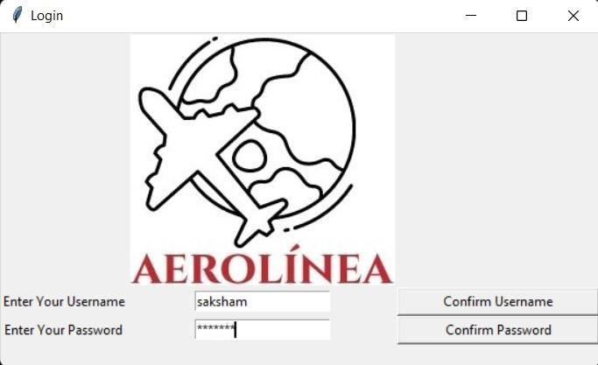

##### Logic for login screen

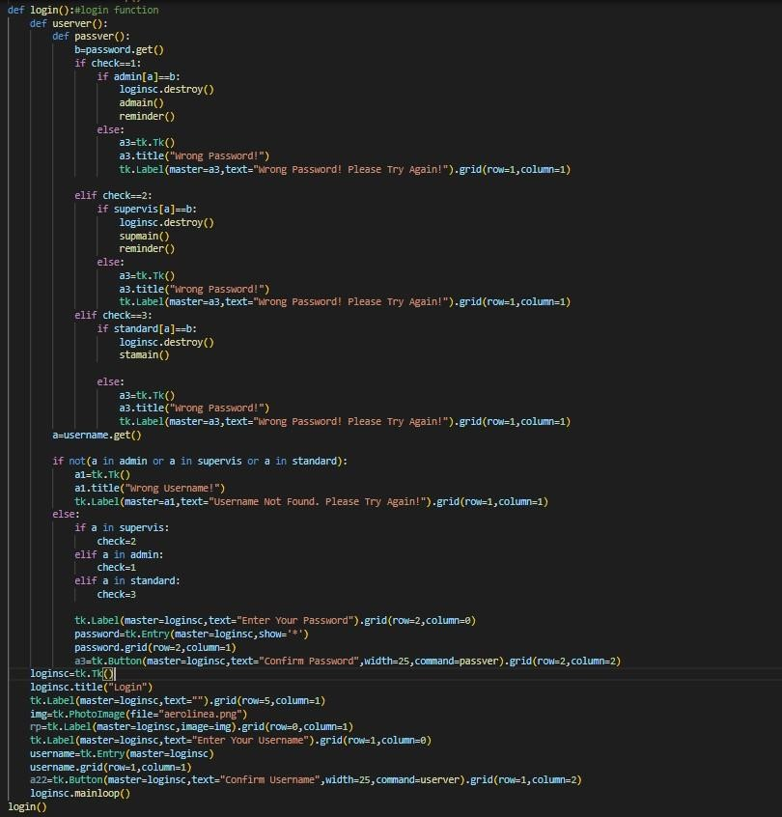

##### Viewing Flight details

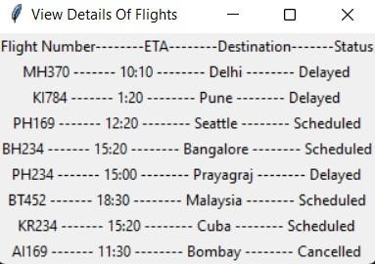

##### Code for Viewing flight details

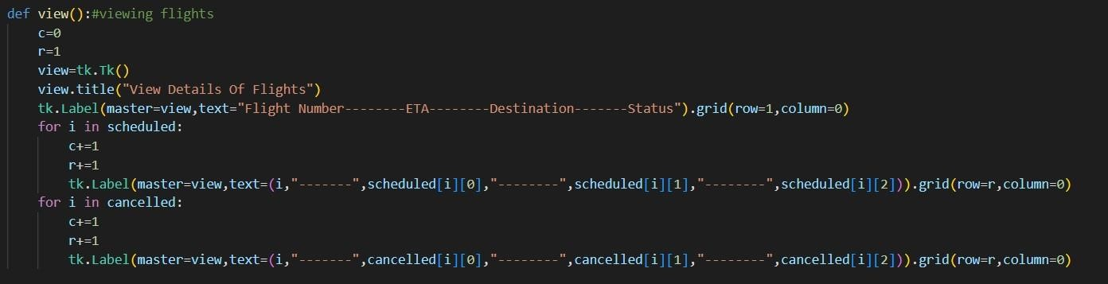

##### Reminder Screen



##### Code for reminder screen

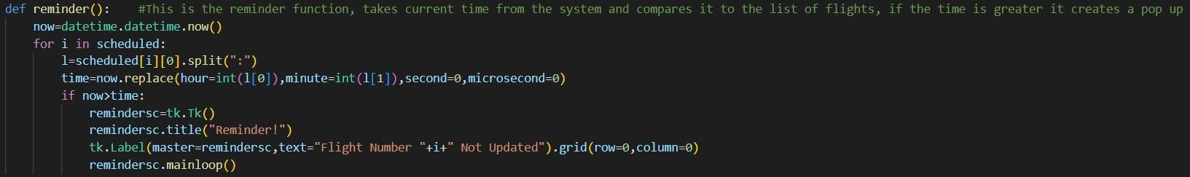

##### Home screen

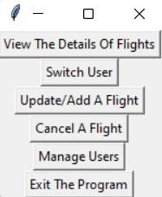

Result:

Thus, the details of architectural design/framework/implementation along with the screenshots were provided.